4.2 Double Integrals Worksheet

- In the xy-plane, the region R is bounded by , and the x-axis. Determine the volume of the solid bounded above by and below by the region R.

- In the xy-plane, the region R is bounded by the curves , and . Sketch the region and determine the volume of the solid bounded above by .

- Use a double integral to compute the area of the region bounded by the graphs of and between and .

- Use a double integral to determine the area of the region D bounded by , on the interval .

- Evaluate where D is the region bounded by circle centered at the origin with radius 2.

- Evaluate where D is the region bounded by and .

- Sketch the region of integration and change the order of integration.

- Evaluate the double integral .

- Evaluate the double integral .

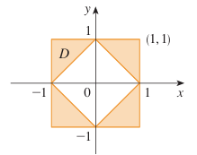
- Express D as a union of regions and evaluate the integral.

